**Data Structures In Python**

**Data structures are code structures for storing and organizing data that make it easier to modify, navigate, and access information.**

## ****Built-in Data Structures****

1. List
2. Tuple
3. Dictionary

## ****User-Defined Data Structures****

Linear & Non-linear

* Linear : Stack & Queue , linked list
* Non-linear : Tree, graph

## ****Stack :**** Stacks are linear Data Structures which are based on the principle of Last-In-First-Out (LIFO) where data which is entered last will be the first to get accessed.

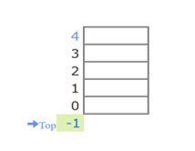

### ****Queue :**** A queue is also a linear data structure which is based on the principle of First-In-First-Out (FIFO) where the data entered first will be accessed first.

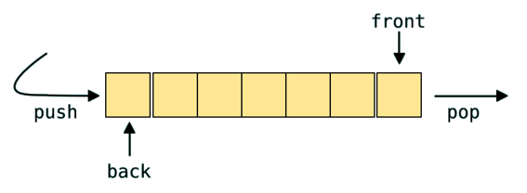

### Linked list : A linked list is a sequence of data elements, which are connected together via links.

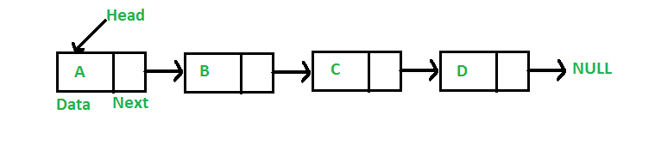

* Types of Lists:

1. Singly-linked list
2. Circular linked list
3. Doubly linked list

* Tree : A tree whose elements have at most 2 children is called a binary tree. Since each element in a binary tree can have only 2 children, we typically name them the left and right child.

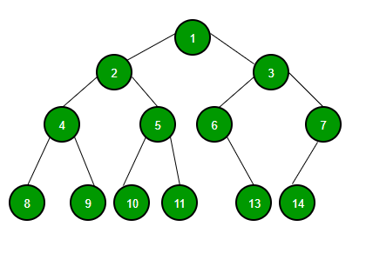

A Binary Tree node contains following parts.

1. Data
2. Pointer to left child
3. Pointer to right child

* B Tree
* B+ tree
* Red black tree
* B Tree
* each node can contain more than one key and can have more than two children.
* It is also known as a height-balanced m-way tree.

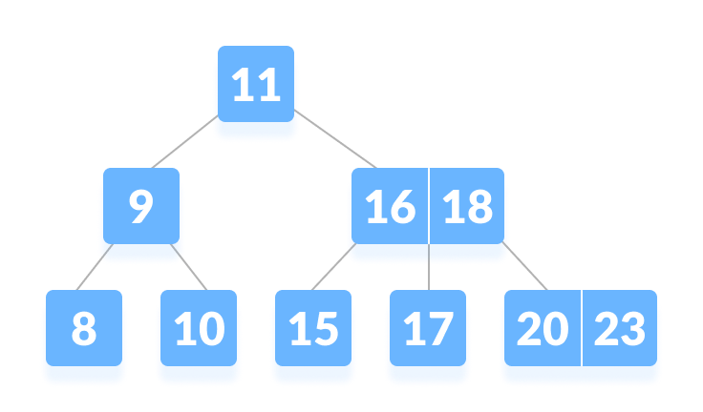

Properties

* Every node has max ‘m’ children
* Minimum children : leaf – 0

Root – 2

Internal nodes – [m/2]

* Every node has max(m-1) keys
* Minimum keys : root node =1

Other nodes = [m/2]-1

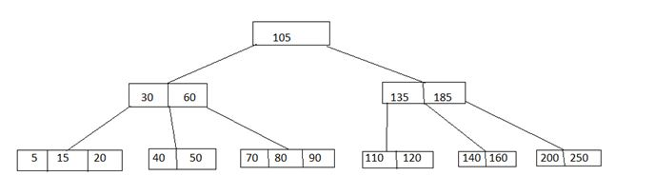

* B+ tree

A B+ tree is an advanced form of a self-balancing tree in which all the values are present in the leaf level.

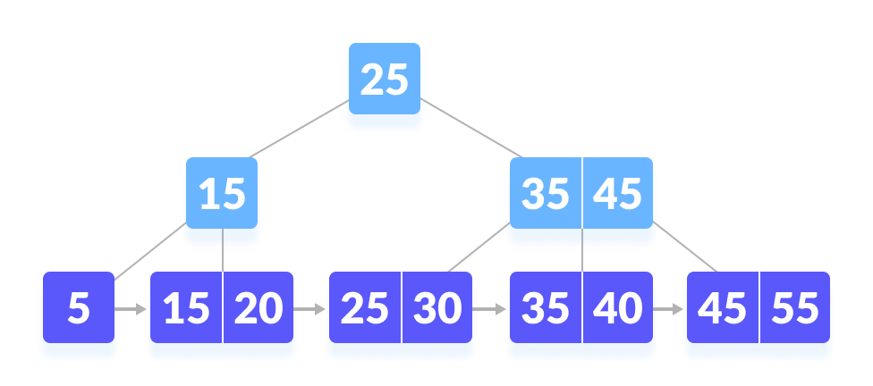

## Properties of a B+ Tree

1. All leaves are at the same level.
2. The root has at least two children.
3. Each node except root can have a maximum of m children and at least m/2 children.
4. Each node can contain a maximum of m - 1 keys and a minimum of  ⌈m/2⌉ - 1 keys.

* Red black tree

Red-Black tree is a self-balancing binary search tree in which each node contains an extra bit for denoting the color of the node, either red or black.

Properties:

1. **Red/Black Property:** Every node is colored, either red or black.
2. **Root Property:** The root is black.
3. **Leaf Property:** Every leaf (NIL) is black.
4. **Red Property:** If a red node has children then, the children are always black.
5. **Depth Property:** For each node, any simple path from this node to any of its descendant leaf has the same black-depth (the number of black nodes).

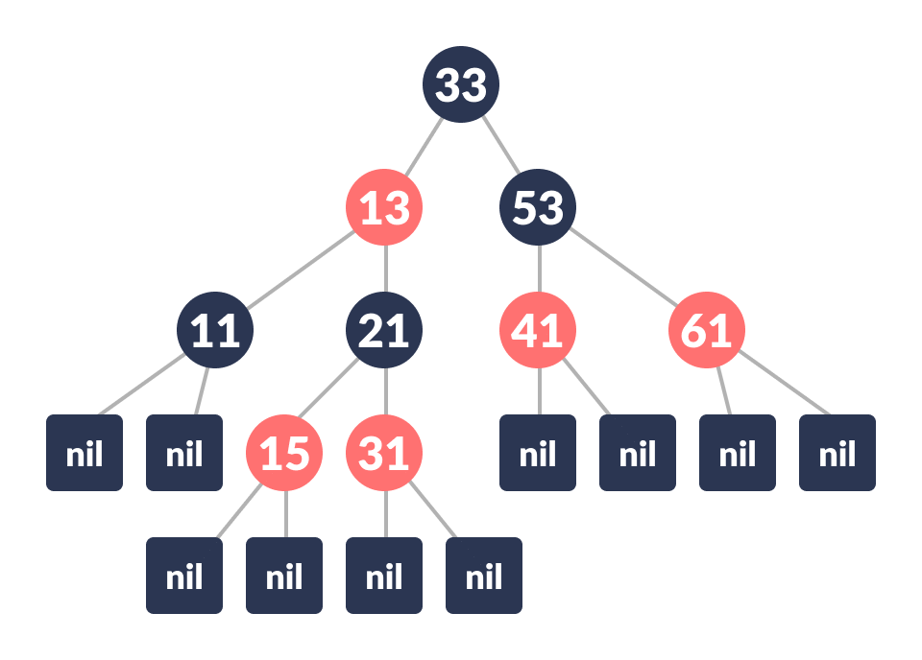

Root=black

No two adjacent red nodes

Count number of black nodes in each path

* If tree is empty, create new node as root node with color black
* If tree is not empty, create new node as leaf node with color red
* If parent of new node is black then exit
* If parent of new node is red then check the color of parent’s sibling of new node:
  1. If color is black or null then do suitable rotation & recolor
  2. If color is red then recolor & also check if parent’s parent of new node is not root node then recolor it & recheck

Sorting

**Selection sort**

Selection sort is a sorting algorithm that selects the smallest element from an unsorted list in each iteration and places that element at the beginning of the unsorted list.

Eg 64 25 12 22 11

**Bubble sort**

**Bubble sort** is a sorting algorithm that compares two adjacent elements and swaps them until they are not in the intended order.

EG: -2 45 0 11 -9

**Merge Sort**

Merge Sort is one of the most popular sorting algorithms that is based on the principle of Divide and Conquer Algorithm.

Here, a problem is divided into multiple sub-problems. Each sub-problem is solved individually. Finally, sub-problems are combined to form the final solution.

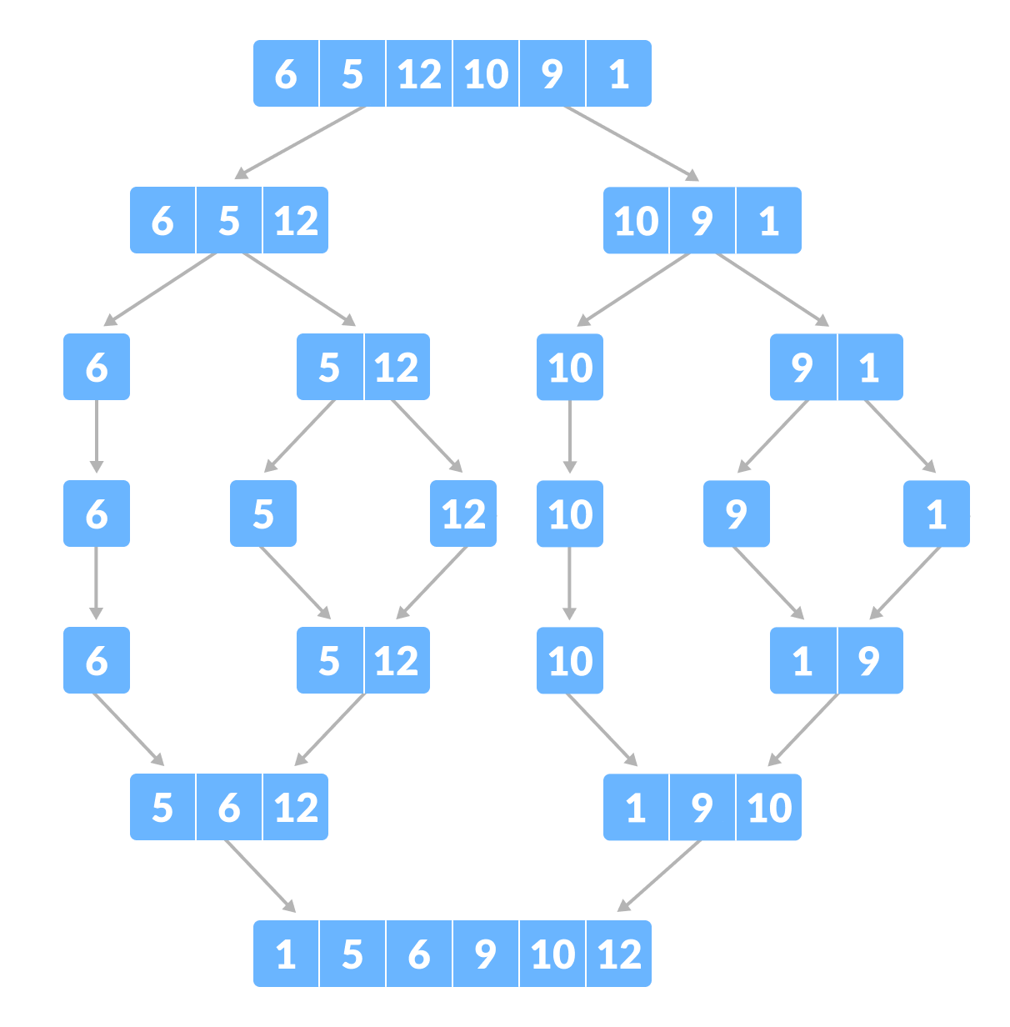

**Quicksort**

Quicksort is a sorting algorithm based on the **divide and conquer approach** where

1. An array is divided into subarrays by selecting a **pivot element** (element selected from the array).  
     
   While dividing the array, the pivot element should be positioned in such a way that elements less than pivot are kept on the left side and elements greater than pivot are on the right side of the pivot.
2. The left and right subarrays are also divided using the same approach. This process continues until each subarray contains a single element.
3. At this point, elements are already sorted. Finally, elements are combined to form a sorted array.

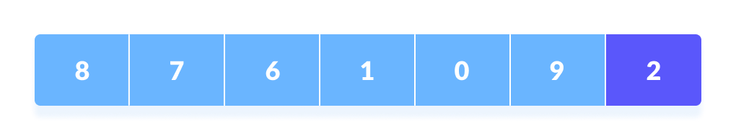

The central library at Mysore has a set of very interesting books and journals. The books are arranged in the alphabetical order of their author names. So it is very easy for the readers to search for the book.

The library has got a set of new books. The librarian wants to arrange them in order too. As some books are already arranged in the order, find a suitable way of arranging the new set of books amidst them.

Write a python program to arrange all the books in the alphabetical order of the author names.

**sort_item_list_by_author():** Accepts the new list of books and returns it sorted in the alphabetical order of their author names.

**add_new_items():** Accepts the new list of books, sorts it and merges it with the existing books in the library.  
**Hint** - Use sort_item_list_by_author() method for sorting the books.

**sort_items_by_published_year():** Sorts the list of books (item_list) based on the increasing order of their published years. If there are multiple items that are published in the same year, then sort them based on the alphabetical order of their author names.

**Note:** While sorting the author names in alphabetical order, ignore the special characters including space, if there are any.

The process of accessing data stored in a serial access memory is similar to manipulating data on a ________  
a) Heap  
b) Binary Tree  
c) Array  
d) Stack

The postfix form of A*B+C/D is?  
a) *AB/CD+  
b) AB*CD/+  
c) A*BC+/D  
d) ABCD+/*

Consider the following operation performed on a stack of size 5.

Push(1);

Pop();

Push(2);

Push(3);

Pop();

Push(4);

Pop();

Pop();

Push(5);

After the completion of all operation, the number of elements present in stack is?  
a) 1  
b) 2  
c) 3  
d) 4

If the elements “A”, “B”, “C” and “D” are placed in a stack and are deleted one at a time, what is the order of removal?  
a) ABCD  
b) DCBA  
c) DCAB  
d) ABDC

What is a full binary tree?  
a) Each node has exactly zero or two children  
b) Each node has exactly two children  
c) All the leaves are at the same level  
d) Each node has exactly one or two children

In a B+ tree, both the internal nodes and the leaves have keys.  
a) True  
b) False

Cosider the below formations of red-black tree.  
[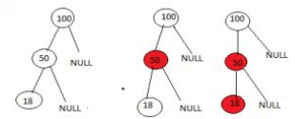](https://www.sanfoundry.com/wp-content/uploads/2017/08/data-structure-questions-answers-red-black-tree-q3.png)  
All the above formations are incorrect for it to be a redblack tree. then what may be the correct order?

a) 50-black root, 18-red left subtree, 100-red right subtree  
b) 50-red root, 18-red left subtree, 100-red right subtree  
c) 50-black root, 18-black left subtree, 100-red right subtree  
d) 50-black root, 18-red left subtree, 100-black right subtree